Recruitment and Selection of Human Resources within the TheCon Organization

Luminița Iosif, Teodora Grigore

Abstract: The purpose of this article is to analyze and present the mode in which the organization Thecon does the selection and recruitment of personnel. This is done through the interview method for the most part, but also trough the analysis of different recruitment announcements. Since Thecon is an organization which specializes in the IT sector, the first part of the presentation is made out of statistical data from Romania about the evolution of the IT sector, followed by the second part of the presentation that is made out of the way in which the Thecon organization attracts new talents to work inside the company.
Keywords: recruitment; human resources selection; work motivation; IT

1. Introduction
Nowadays the IT domain is one of the most popular branches of work in the world and is still evolving because of the rapid rhythm in which technology is advancing. And with this development, the need for specialists also rises, those who need to be able to adapt to the new needs as soon as they appear, such as new programming languages, new technological devices, tools, applications and so on.
The IT market from Romania is one that offers plenty of opportunities for personal development and learning, the demand for workers is high and the employers implement all kinds of benefits in the company in order to retain as many specialists as possible and to lower the fluctuation of personnel. In this context, a series of researches has been made, either if we discuss about the activity of women in this field of work (Iosif & Huzum, 2018), the motivation of the employees (Miron, 2009) or other subjects. Although the salaries are way over the average pay in Romania, many of the specialists still choose to work abroad. Even if Romania is understaffed in specialists, it still lands on the 6th place in the world and the first in the whole Europe at the number of employees in the IT branch.
The IT industry in Romania represents one of the most prosperous sectors of the economy, which has evolved considerably in the last few years. Registering in the year 2019 a business value of almost 6 milliards of euros, representing approximately 5,5 of the country’s PIB. If we look at the cities that had the highest influence, we can find that the capital, Bucharest, is contributing 63% of the revenue, the Nord-West region is providing 18% of the revenue, the West region is providing 5%, the Central area 6%, the Nord-East 5%, and the rest 3% is being split between the South, South-East and South-West.
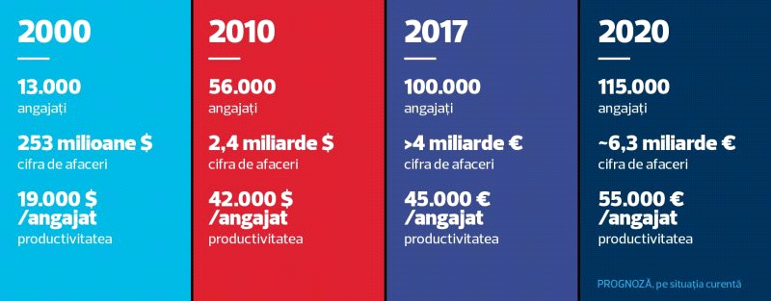
Figure 1. The Evolution of the IT Industry in Romania
Source: ANIS
There is a high demand of IT workers, that has been caused by the lack of an educational system that can train such specialists, and the fact that those who become qualified tend to work abroad, and this is why the process of recruitment and selection is such a key component that IT organizations have to focus on, as the organizations can’t stay relevant on the market without the human resource they are capable of retaining and developing inside the company. Although the educational system manages to produce approximately 7.000 graduates in the IT domain, the demand is around 12.000 specialists a year.
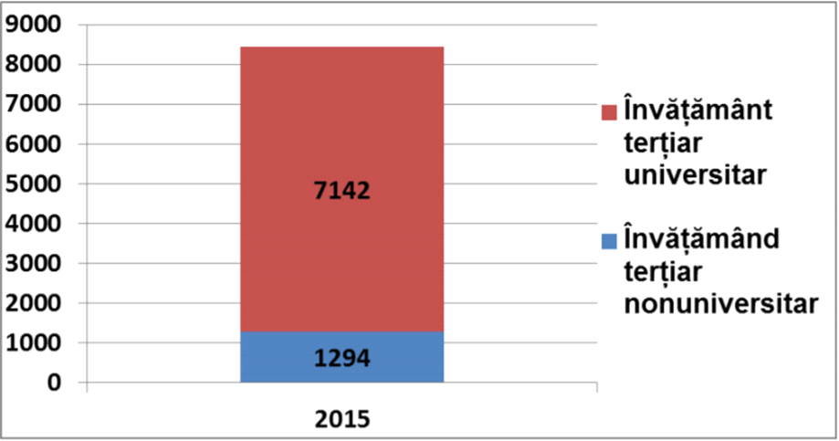
Figure 2. The Number of IT graduates
Source: NBR calculations based on Eurostat data
2. The Selection and Recruitment Process
The recruitment of personnel represents the process trough which the organization searches and attracts candidates suitable for the vacant jobs withing the departments of the company. Within the recruitment process, the profile and characteristics of the candidate must be analyzed from the start with the help of the job description. The final objective is to identify the best option that could contribute in reaching the organization target. The recruitment process must generate a high enough number of possible suitable candidates for vacancies in the organization. The recruitment process can either be permanent or only when there is a need for more employees. (Manolescu, Lefter & Deaconu, 2007, p. 91).
The main methods of external recruitment of the personnel are the means of publicity (Internet, press, television, radio), internships (a timed integration of an individual inside the company without employing that person), head-hunting companies (used in the case of management positions or those with a high degree of specialization), workshops, the use of recruiting specialists, the candidate file (databases with potential candidates).
The method that had the highest success lately and is keep increasing in popularity is online recruiting, which is mostly done trough the use of specialized platforms (such as Ejobs, BestJobs, Jooble, Hipo, Indeed, etc.), trough the help of social media, or through the website of the organization, where there can be a special section dedicated to open job posts and receiving CV’s.
According to a study done by My HR Lab in 2018, the recruitment trough Social Media has become the main method used by specialists in human resources to find and attract candidates. The most used platform is LinkedIn.
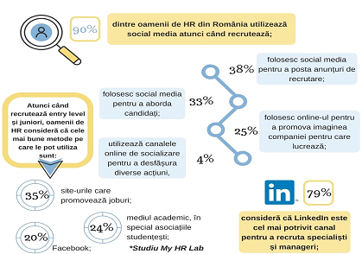
Figure 3. The Use of Social Networks in recruitment
Throughout the study, a total of 456 subjects involved in human resources, specialists in recruitment for different companies present in Romania, that have at least 10 up to 10.000 employees. The results of the research have showed that 40% of the specialists (with 3-7 years of experience), 35 are seniors (with 7 or more years of experience) and the rest 25% are juniors (with 1 to 3 years of experience): 35% of them are recruiting for companies that work in the IT&C industry, 16% in the professional services sector, 10% in the auto industry, 9% in the retail industry/FMCG, 7% in the financial sector, 4% work for recruiting agencies, 3% in the pharmaceutical industry. 62% of the subjects live in Bucharest, 10% in Cluj-Napoca, 7% in Iasi, 5% in Timisoara, 7% in Brasov and Sibiu and the rest of 9% in cities like Ploiești, Pitești, Oradea, Alba Iulia, Galați or Constanța.
The selection process in human resources assume the picking of the right candidate based on the job description, followed by the personal evaluation done through specific means. This process requires an objective analysis of the concordance between the characteristics of the vacancy and the skills and knowledge of the job seeker. The selection of the candidates is realized after the recruitment of the personnel, which must gather a sufficiently large number of applicants, from which the most prepared will be chosen (Păuș, 2006, p. 206).
The stages of the recruitment process are: the gathering of the CV’s, the primary selection (based on CV’s), the secondary selection (based on interview, test, work-sample, etc.), checking employee referrals, taking the decision about the candidates, making an offer to the picked candidate, followed by the signing of the contract (Manolescu, Lefter, Deaconu, 2007, p. 97).

3. Research on the Thecon Organization
The purpose of the research is that of describing the recruitment and selection process from within the company Thecon. The objectives of the research being:
- The delimitation of the recruitment and selection steps;
- The identification of the used recruitment channels;
- Analyzing the public recruitment announcements;
- Presenting the tools used for personnel selection;
- Identifying the way in which the company brand helps at attracting candidates.
The methods used for reaching the objectives are: the interview method and the analysis of the recruitment announcement content.
There has been a total of three interviews realized with the purpose of this research, one interview has been made with the former manager from Talent Capital, Sorin Șerban, and the other two interviews were made with two employees from Thecon that got employed between January 2020 up to May 2020.
The first interview that was taken with the former manager was made up from twenty-two questions. In the first four questions were addressed subjects such as informations about the two organizations: Thecon and Talent Capital. The next eight questions were made regarding the recruitment and selection process from within the organization Thecon. The rest of the questions were focused on the brand of the recruiter and of the organization, as well as the IT branch in general. In the last part of the interview, the advantages of externalizations were revealed, as well as perspectives about the future of the Thecon organization, about the specific work domain the corporation operates in, and about the collaboration of the two organizations.
Within the contents of this article only the data gathered from the interview with the former manager from the Talent Capital Corporation will be used.

3.1. The Thecon Organization
Thecon is an organization established in the year 2006, having headquarters in Bucharest and Galati and is specialized in providing IT services (web design, web development, SEO, SEM and SMM). The mission of the organization is to exceed the expectations of their clients each day, trough delivering new, creative and innovative solutions that are both tailored for their customer demands and performed at the highest technical quality. Within the Thecon Corporation, another business formed, an online shopping platform, Clește.ro, established in the year 2017 (specialized in the selling of electronics).
The Thecon team is made up of approximately forty employees and rising. The personal and career development of the team is a priority, constantly being supported by the management of the company. This is being realized with the help of a warm and friendly environment that motivates the team.
Thecon does not have it’s own Human Resources department, instead the recruitment functions were externalized to a specialized human resources company from Galati, named Talent Capital, which also offered human resource consultancy, while the personnel management part is carried out from internal sources.
Talent Capital is a company specialized in consultation and Human Resources. The purpose of the company is to replace or supplement the functions of the human resources department in an organization. Talent Capital offers customers (small and medium sized companies from the region Galati-Braila) personalized services according to their needs, flexibility and experience.

3.2. The Recruitment and Selection Process within the Corporation Thecon
In order to describe the recruitment and selection process of the Thecon organization, an interview with the former manager of the organization Talent Capital has been made.
Within the interview with the former manager of Talent Capital, were addressed subjects such as the steps of recruitment and selection process of the organization Thecon, used recruitment platforms, employee’s brand, the externalization of the human resources department, the IT domain, etc.
Thecon collaborates with Talent Capital since October 2017 and benefits human resources services: “Services of recruitment and selection as well as consulting in human resources in general”. Talent Capital has recruited for Thecon for different job openings, such as: “Content writer, programmers, Manager Assistant, sales operator of the online shop Clește.ro, Sales Executive, Angular Developer, Customer Support”.
The recruitment and selection process that are being used by Talent Capital for Thecon contain multiple steps that the Talent Capital former manager has shaped during the interview. The first stage is making of the profile of the right candidate to fill the position: “The recruitment begins with the shaping of the perfect candidate profile”. This step is being realised with the help of the job description file schematics, that contains the responsibilities of the employee, the frequency with which they perform them, the duration of these tasks, with whom they interact, what tools or materials they use. Based on all of those factors, there are established requirements and tasks that are required to carry out this post. Those requirements can be: basic, general or specific, which means strictly referring to the job, such as being able to work in a specific program. After that, the education, experience and knowledge in the domain are being taken into consideration.
After the shaping of the profile is done, the next step takes place, that is picking a communication channel with the candidates, the recruitment platforms that are going to be used by the organization. Thecon uses both recruitment platforms, as well as Social Media: “The main platforms that we utilize are eJobs, BestJobs, as well as Facebook. We also tend to use LinkedIn, as well as free platforms such as Jooble, Jobssup and jobZZ”.
The profile of the candidate as well as how often he interacts with the platforms is important in picking the right communication channel, in order to make sure that the job offering is being seen by the right people: “the presence of a large number of similar ads, which indicates the existence of a potential << pool >> of candidates on that platform and secondly, where such data are available, the presence of suitable candidates with active accounts in the platform”, as well as the budget the organization has allocated for this process: “To not be neglected in choosing the platform is the allocated budget for the recruitment and selection of the post, which often limits or favors the use of a particular platform”.
The selection process begins with the receipt of applications from those who apply. Recruiters evaluate CVs received and assigned a certain status depending on the platform on which the recruitment is performed. On Facebook platform, candidates apply with a resume that they must complete. After viewing the CV’s, the recruiter can select the status of an asterisk that means “qualifies”, a red dot that means “not qualified” and blue dot with a question mark that means is needed more information.
On the Ejobs platform, there can be three statuses selected: the red one being rejected, the yellow one being a medium and green being good. After selecting the CV’s, the candidates can receive the rejected or medium mark. The ones with medium mark are then being contacted for a phone interview, and if they pass it, then they move to the face to face interview and they gain the green mark (the good one).
The phone interview that is being done with the ones that pass the preliminary CV phase tends to last for around 10-15 minutes and is usually made up from around 5-6 questions. In the first part of the interview, the recruiter presents himself and tells the candidate the reason why he has been called for. After that he is asked if he remembers for what job offering he applied to. If he does not remember, the recruitment specialist will remind him about it, and then ask him if he is still interested about the job opening, if the answer received is an affirmative one, he is then informed that the first step of the selection is going through the the phone interview, after which the recruiter asks for confirmation from the candidate so that the phone interview can start. If the candidate can’t hold the interview at that time then it is moved to a different date. The questions addressed toward the candidate are focused on the reason he applied to the job, about his qualifications, followed by more informations about the job, and toward the end of the interview questions about the expectations he has from the company. At the end of the interview the candidate receives thanks for the time accorded and is told what follows next. If the job position is a more complex one, the candidates will receive a test: “If the post demands it, they will receive a test or a homework project to realize, if the post does not need it, they are being called to a face to face interview with the recruiters, followed by an interview with the manager of the post”.
If a test or project was required, the next step of the selection process is a direct interview with the recruiter and the manager of the post, but if this step was skipped, an interview with the recruiter is being done, in which elements such as why the candidate choose the post, the image the candidate had about the job after he read the job offer and he received the phone interview are looked into. In this phase, the candidate receives details about the job, the team he will work with, and about the company he will work in. He will also receive answers about any questions he might have. From the candidates that take the face to face interview, only a number of candidates is being chosen to continue to the next interview with the manager. This interview is based more on the technical level of the job, it’s also a good opportunity for the manager to find which candidate would suit his team the most, from both an ability and knowledge point of view, as well as communication and integration skills. After this last interview takes place, a candidate is being chosen, an offer is being communicated, and if he does not agree with it, the recruiter is needed to create a new plan. “... in the end, a candidate is being chosen and given an offer. If he accepts, he will then sign the job contract. If the chosen one refuses, usually the next best candidate is being chosen and gets the offer, or the recruitment and selection process is being remade”.
For Thecon, there is quite a pool of possible candidates, however there is a high competition level from other companies: “Because the existence of the University that produces a steady number of IT specialists each year, there is an active market, however it’s a market that constantly loses new talents as the local economy level is not high enough to keep them”.
On a future perspective, the former manager of Talent Capital thinks that the demand for IT specialists will keep being high, even more, withing the Thecon organization, taking in consideration the present for context, the need of specialists will raise, and the total number of personnel will be raised with 20-25% by the end of the year: “... a lot of companies are now realizing how much they need a digitalization of their business, I believe the demands will raise with at least 20-25% in 2020”.
One thing that could be implemented within the Thecon organization that former manager of Talent Capital thinks it would help the recruitment process, is a recommendation program, in which the current employees of the company can recommend someone they know, and if they do, they will get rewarded if the recommended person is being employed. “Yes, an idea would be an Employee Referral program”.
At the end of the interview, about the collaboration between Thecon and Talent Capital, he added: “...new services will be added”, and the advantages of the externalization of the human resources department would be: “a raise in the quality and performance of the outsourced department, a better control of the costs and a raise in flexibility, and if the collaboration is well tightened, the level of management of the human resources policies can be improved”.

3.3. The Recruitment Ad
In the figure below we will find an example of a recruitment ad. This one is for the Content Writer job offering, published on the date of March 20 on the Thecon Facebook page. This announcement was published under the shape of a promoted ad so that it can reach a higher amount of people, especially those that have experience in the field.
The performance of the recruitment ad was made up from a total of 225 people accessing the ad, a total of 52 reactions, comments and shares, reaching a number of 2627 views. The post defines itself through an image that represents the key element of the job, that being the creation of online content.
The colors used are bright, the most predominant one being yellow, which is a happy color that expresses optimism and energy. The first part of the recruitment ad has been made around attracting the readers attention, being made up from several questions, which resumes the job and stirs curiosity trough the wordplay used. We can also observe that “call to action”, through the phrase: “Come join our team!”. Within the recruitment ad is specified the way in which candidates can applied, and a little task is also implemented: along the CV, the candidates must write a short presentation about themselves and of a project/experience that they are proud of. The finale of the ad is made of a few benefits of the job. An element that makes the recruitment ad to be more playful and familiar is the use of emoticons.
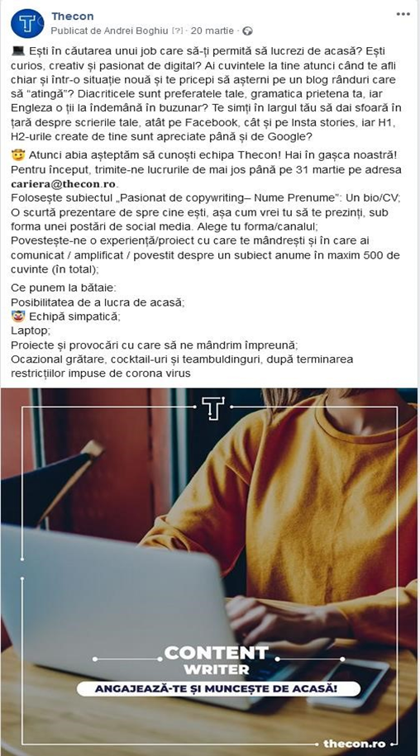
Figure 4. Recruitment ad - Content Writer
4. Conclusions
The recruitment and selection are complex processes, realized by human resources department. It requires time, financial costs, and experienced specialists. The recruitment process is of importance for the company, as all the others departments depend on it. Without qualified employees that can finish their tasks and help the company develop, it will lag behind the competition.
Amongst the recruitment and selection process, the human resources specialists are tasked with a multitude of roles, such as: first of all, they must be a marketing person, they must be able to identify the target audience, designing a tailored recruitment make it as attractive as possible. Within the selection part, they must be an acquisitions man, able to pinpoint what exactly is asked from the candidate by the employer, as well as to keep an objective and critical thinking. As for the offering part of the process, the recruiter returns in the marketing role and sell the job offering and the company as good as possible, creating the best image he can think of in order to facilitate a positive answer from the targeted candidate.
The way the organization promotes itself in the online environment highlights this importance that the team has, that is why many candidates who apply or are apprentices at Thecon are pleasantly surprised of the members of the organization and the way they interact, seeing them, from the outside, as a family. In my opinion, this thing gives the company a benefit on both reducing the personnel fluctuation, as well as attracting new candidates that see from the outside the welcoming and positive vibe given by the employees.
Within the IT domain, in which specialists are always in high demand and and it is desired to attract them by all means, it’s very important that the organization knows how to present itself to them. The recruiters must put themselves in the skin of such specialists and think of the best way to attract them. As the competition is quite high, organizations must know how to differentiate themselves from the rest, by using unique elements that are not limited to material benefits that they facilitate the employees with, but other type of benefits as well. There is also the risk that the company can lose some employees that they invested time and money in as to form them, trough the head-hunting method used by the competition. That’s why, once employed, the employees must benefit from a well-rewarded motivational system, being given constant feedback, having their needs and opinions answered, and that the management team tries its best to resolve any issue or need that might appear as quickly as possible, but also providing equipment and other benefits that can make the difference.
Taking in consideration the fact that Thecon externalized the recruitment and selection department of the company toward Talent Capital, but also thanks to the consulting given by them about human resources, we can see a high level of success in finding appropriate candidates and in keeping employees within the company. The advices of the specialists, that are connected to the job market as well as knowing the needs of the targeted candidates were put often in application and had positive results. That’s why, a guiding hand from the exterior of the company is more than needed when the primary activity of the company is not from the human resources domain.
The specialists in the IT domain are and will be for quite a long period of time one of the most desired and hunted type of candidates seeked by recruiters, even within the Thecon organization, as the digitalization is an ascending process. The number of job openings will significally rise from year to year, the company being into a continuous growth.

References
Grigoraș, V.; Leonte, A. & Tănase, A. Studiu al evoluțiilor sectorului IT&C în România. https://www.bnr.ro/DocumentInformation.aspx?idInfoClass=8161&idDocument=26052&directLink=1.
Iosif, L. & Huzum C. (2018). Women from IT domain in Romania. Acta Universitatis Danubius. Communicatio, vol 12, nr. 2, pp. 5-12. http://journals.univ-danubius.ro/index.php/communicatio/article/view/5288/4745.
Manolescu, A.; Lefter, V. & Deaconu, A. (coord.) (2007). Managementul resurselor umane. Bucharest: Pro Universitaria.
Miron, L. (2009). Motivaţia muncii – formă de prevenire a fluctuaţiei personalului. Acta Universitatis Danubius. Communicatio, nr.1, Galati: Editura Universitară Danubius, pp. 126-148. http://journals.univ-danubius.ro/index.php/communicatio/article/view/378.
Păuș, V. A. (2006). Comunicarea și resurse umane. Iasi: Polirom.
https://codecool.com/ro/blog/domeniul-it/.
https://idea-perpetua.ro/studiul-pietei-it-din-romania-pentru-anul-2020/.
https://www.managerexpress.ro/companie/recrutarea-prin-social-media-in-romania.html.
https://talentcapital.ro/.
https://thecon.ro/.

“Dunarea de Jos” University of Galati, Romania, Address: 47 Domneasca, Galati, Romania, Corresponding author: luminita.iosif@ugal.ro.
“Dunarea de Jos” University of Galati, Romania, Address: 47 Domneasca, Galati, Romania, E-mail: grigore.teodora12@gmail.com.
https://codecool.com/ro/blog/domeniul-it/.
https://idea-perpetua.ro/studiul-pietei-it-din-romania-pentru-anul-2020/.
Employers' Association of the Software and Services Industry.
https://www.managerexpress.ro/companie/recrutarea-prin-social-media-in-romania.html.
https://thecon.ro/.
https://talentcapital.ro/.

